Code:
#include <stdio.h>
#include <stdlib.h>

typedef struct {
int *Q;
int size;
int front;
int rear;
} CQueue;

CQueue* createQueue(int capacity) {
CQueue *queue = (CQueue *)malloc(sizeof(CQueue));
if (queue == NULL) {
printf("Memory allocation failed!\n");
return NULL;
}

queue->Q = (int *)malloc(capacity * sizeof(int));
if (queue->Q == NULL) {
printf("Memory allocation for queue array failed!\n");
free(queue);
return NULL;
}

queue->size = capacity;
queue->front = -1;
queue->rear = -1;

printf("Queue created with capacity %d\n", capacity);
return queue;
}

int isEmpty(CQueue *queue) {
return (queue->front == -1);
}

int isFull(CQueue *queue) {
return ((queue->rear + 1) % queue->size == queue->front);
}

void enqueue(CQueue *queue, int value) {
if (isFull(queue)) {
printf("Overflow! Queue is full. Cannot insert %d\n", value);
return;
}

if (isEmpty(queue)) {
queue->front = 0;
queue->rear = 0;
}
else {
queue->rear = (queue->rear + 1) % queue->size;
}

queue->Q[queue->rear] = value;
printf("Enqueued %d at position %d\n", value, queue->rear);
}

int dequeue(CQueue *queue) {
if (isEmpty(queue)) {
printf("Underflow! Queue is empty. Cannot delete.\n");
return -1;
}

int deleted = queue->Q[queue->front];

if (queue->front == queue->rear) {
queue->front = -1;
queue->rear = -1;
}
else {
queue->front = (queue->front + 1) % queue->size;
}

printf("Dequeued %d from position %d\n", deleted, (queue->front - 1 + queue->size) % queue->size);
return deleted;
}

int frontVal(CQueue *queue) {
if (isEmpty(queue)) {
printf("Queue is empty. No front element.\n");
return -1;
}
return queue->Q[queue->front];
}

int rearVal(CQueue *queue) {
if (isEmpty(queue)) {
printf("Queue is empty. No rear element.\n");
return -1;
}
return queue->Q[queue->rear];
}

void displayQueue(CQueue *queue) {
if (isEmpty(queue)) {
printf("Queue is empty.\n");
return;
}

printf("Queue Elements (Front to Rear): ");
int i = queue->front;

if (queue->front <= queue->rear) {
while (i <= queue->rear) {
printf("%d ", queue->Q[i]);
i++;
}
}
else {
while (i < queue->size) {
printf("%d ", queue->Q[i]);
i++;
}
i = 0;
while (i <= queue->rear) {
printf("%d ", queue->Q[i]);
i++;
}
}
printf("\n");
}

void freeQueue(CQueue *queue) {
if (queue != NULL) {
if (queue->Q != NULL) {
free(queue->Q);
}
free(queue);
}
printf("Queue memory freed.\n");
}

int main() {
printf("===== CIRCULAR QUEUE IMPLEMENTATION =====\n");

int capacity, choice, value;
CQueue *queue = NULL;

printf("Enter the size of the queue: ");
scanf("%d", &capacity);

queue = createQueue(capacity);

if (queue == NULL) {
return 1;
}

while (1) {
printf("\n---MENU---\n");
printf("1. Enqueue\n");
printf("2. Dequeue\n");
printf("3. Display Queue\n");
printf("4. Front Value\n");
printf("5. Rear Value\n");
printf("6. Is Empty\n");
printf("7. Is Full\n");
printf("8. Exit\n");
printf("Enter your choice: ");
scanf("%d", &choice);

switch(choice) {
case 1:
printf("Enter an element to enqueue: ");
scanf("%d", &value);
enqueue(queue, value);
break;

case 2:
dequeue(queue);
break;

case 3:
displayQueue(queue);
break;

case 4:
if (!isEmpty(queue)) {
printf("Queue front: %d\n", frontVal(queue));
}
break;

case 5:
if (!isEmpty(queue)) {
printf("Queue rear: %d\n", rearVal(queue));
}
break;

case 6:
if (isEmpty(queue)) {
printf("Queue is EMPTY\n");
} else {
printf("Queue is NOT empty\n");
}
break;

case 7:
if (isFull(queue)) {
printf("Queue is FULL\n");
} else {
printf("Queue is NOT full\n");
}
break;

case 8:
freeQueue(queue);
printf("\n===== PROGRAM COMPLETED =====\n");
return 0;

default:
printf("Invalid choice! Please try again.\n");
}
}

return 0;
}

Output sample Table:
Sr. No. | Input | Expected Output |  | Actual Output
 | Create Queue: size=5;  Call frontVal() | Queue is EMPTY |  | 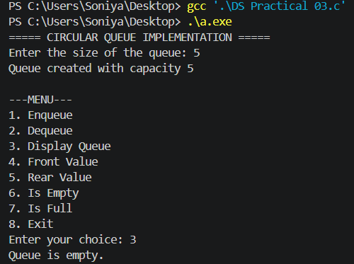
 | Create Queue: size=3; Enqueue  10;  Call frontVal() | Queue front: 10 |  | 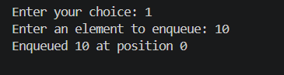
 | Create Queue: size=3; Enqueue  10, 20, 30; Call rearVal() | Queue rear: 30 |  | 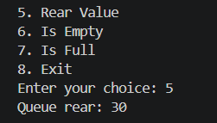
 | Create Queue: size=3; Enqueue  10,20,30; Enqueue 40 | Queue is FULL  (Overflow) |  | 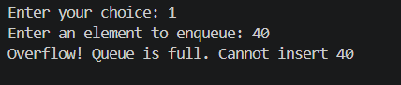
 | Create Queue: size=3; Dequeue | Queue is EMPTY  (Underflow) |  | 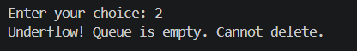
 | Create Queue: size=3; Enqueue 5; Dequeue | Dequeued: 5; Queue is EMPTY |  | 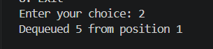
 | Create Queue: size=4; Enqueue 10,20,30,40; frontVal; Dequeue×2; Enqueue 50,60; frontVal |  | Queue front: 30 | 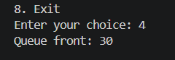
 | Create Queue: size=1; frontVal; Enqueue 99; Enqueue 100 | Queue is FULL |  | 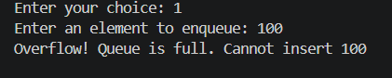
 | Create Queue: size=1; Enqueue 99; Dequeue×2 | Dequeued: 99; Queue is EMPTY |  | 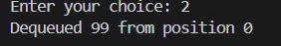  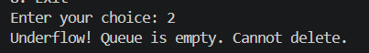
- jhgg | Create Queue: size=3; Enqueue 11,22,33; Dequeue; rearVal; Enqueue 44,55 | Queue is FULL |  | 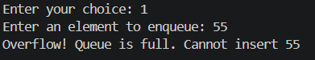
 | Create Queue: size=4; Enqueue 1,2,3; Dequeue×3 | Queue is EMPTY |  | 